Python Functions
Python Functions is a block of statements that return the specific task. The idea is to put some commonly or repeatedly done tasks together and make a function so that instead of writing the same code again and again for different inputs, we can do the function calls to reuse code contained in it over and over again.
Some Benefits of Using Functions
- Increase Code Readability
- Increase Code Reusability

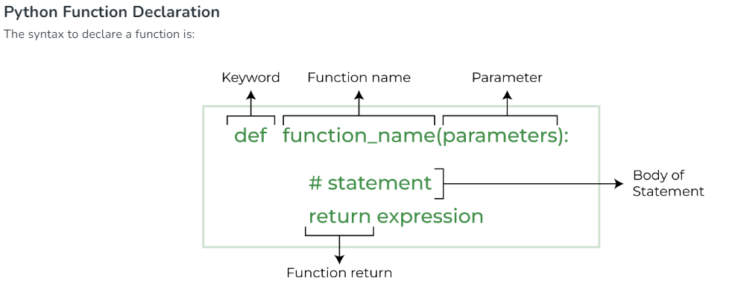
Types of Functions in python:
- Built-in library function: These are standard functions in python that are available to use.
- User-defined Functions: We can create our own functions based on out requirements.
Example:
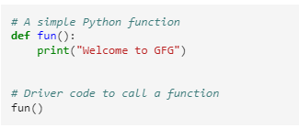
Python function with parameter with return type(return type is possible only in Python3.5)
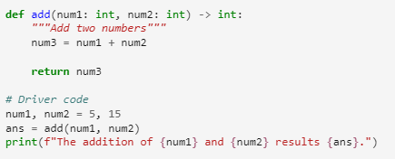

Types of Python Function Arguments:
Python supports various types of arguments that can be passed at the time of function call.
- Default Arguments.
- Keyword Arguments.
- Positional Arguments.
- Arbitrary Arguments (variable-length arguments *args and **kwargs)

Default Arguments:
A default argument is a parameter that assumes a default value if a value is not provided in the function call for that argument.
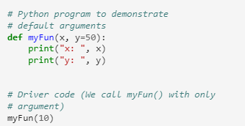
Keyword Arguments:
Keyword-only arguments mean whenever we pass the arguments(or value) by their parameter names at the time of calling the function in Python in which if you change the position of arguments then there will be no change in the output.
Benefits of using Keyword arguments over positional arguments
On using keyword arguments you will get the correct output because the order of argument doesn’t matter provided the logic of your code is correct. But in the case of positional arguments, you will get more than one output on changing the order of the arguments.

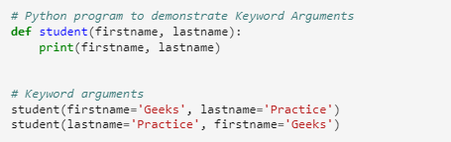
Positional Arguments:
Position-only arguments mean whenever we pass the arguments in the order we have defined function parameters in which if you change the argument position then you may get the unexpected output. We should use positional Arguments whenever we know the order of argument to be passed.
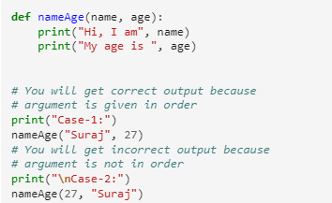
Arbitrary keyword Arguments:
In Python Arbitrary Keyword Arguments, *args, and **kwargs can pass a variable number of arguments to a function using special symbols. There are two special symbols:
- *args in Python (Non-Keyword Arguments)
- **kwargs in Python (Keyword Arguments)

What is Python *args?
The special syntax *args in function definitions in Python is used to pass a variable number of arguments to a function. It is used to pass a non-keyworded, variable-length argument list.
- The syntax is to use the symbol * to take in a variable number of arguments; by convention, it is often used with the word args.
- What *args allows you to do is take in more arguments than the number of formal arguments that you previously defined. With *args, any number of extra arguments can be tacked on to your current formal parameters (including zero extra arguments).
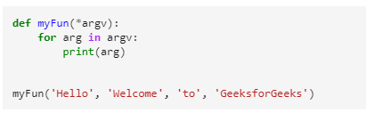
What is Python **kwargs?
The special syntax **kwargs in function definitions in Python is used to pass a keyworded, variable-length argument list. We use the name kwargs with the double star. The reason is that the double star allows us to pass through keyword arguments (and any number of them).

A keyword argument is where you provide a name to the variable as you pass it into the function.
One can think of the kwargs as being a dictionary that maps each keyword to the value that we pass alongside it. That is why when we iterate over the kwargs there doesn’t seem to be any order in which they were printed out.
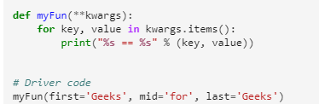
Both *args and **kargs together:
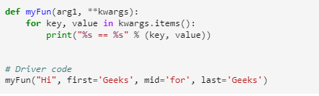

Function within another Function:
A function that is defined inside another function is known as the inner function or nested function. Nested functions can access variables of the enclosing scope. Inner functions are used so that they can be protected from everything happening outside the function.
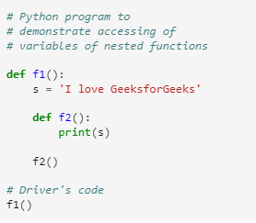
Anonymous Functions in python
An anonymous function means that a function is without a name. As we already know the def keyword is used to define the normal functions and the lambda keyword is used to create anonymous functions.
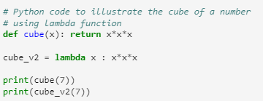

Recursive Functions in Python
Recursion in Python refers to when a function calls itself. There are many instances when you have to build a recursive function to solve Mathematical and Recursive Problems.
Using a recursive function should be done with caution, as a recursive function can become like a non-terminating loop. It is better to check your exit statement while creating a recursive function.
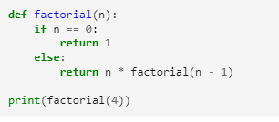

Return Statement in Python Function
The function return statement is used to exit from a function and go back to the function caller and return the specified value or data item to the caller

Python Try Except
Error in Python can be of two types i.e. Syntax errors and Exceptions. Errors are the problems in a program due to which the program will stop the execution. On the other hand, exceptions are raised when some internal events occur which changes the normal flow of the program.
Some of the common Exception Errors are :
- IOError: if the file can’t be opened
- KeyboardInterrupt: when an unrequired key is pressed by the user
- ValueError: when the built-in function receives a wrong argument
- EOFError: if End-Of-File is hit without reading any data
- ImportError: if it is unable to find the module

Try Except:
Try and Except statement is used to handle these errors within our code in Python. The try block is used to check some code for errors i.e the code inside the try block will execute when there is no error in the program. Whereas the code inside the except block will execute whenever the program encounters some error in the preceding try block.
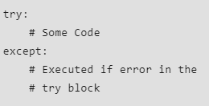
How try() works?
- First, the try clause is executed i.e. the code between try.
- If there is no exception, then only the try clause will run, except clause is finished.
- If any exception occurs, the try clause will be skipped and except clause will run.
- If any exception occurs, but the except clause within the code doesn’t handle it, it is passed on to the outer try statements. If the exception is left unhandled, then the execution stops.
- A try statement can have more than one except clause
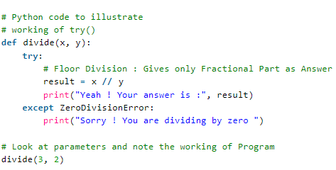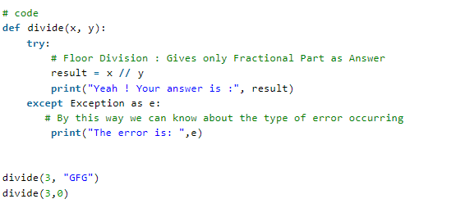

Else Clause:
In Python, you can also use the else clause on the try-except block which must be present after all the except clauses. The code enters the else block only if the try clause does not raise an exception.
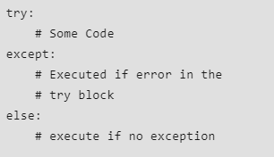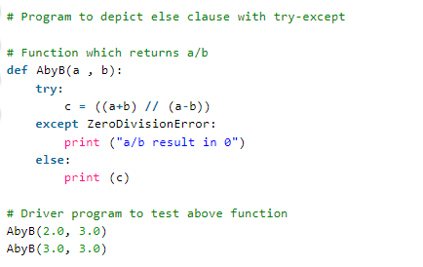
Finally keyword:
Python provides a keyword finally, which is always executed after the try and except blocks. The final block always executes after the normal termination of the try block or after the try block terminates due to some exceptions.
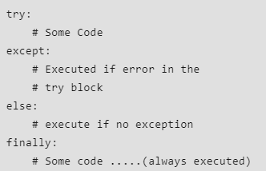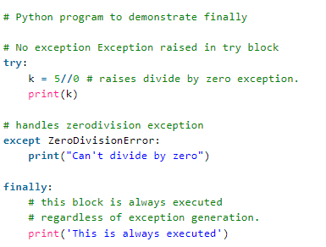

User Defined Exceptions:
Exceptions need to be derived from the Exception class, either directly or indirectly. Although not mandatory, most of the exceptions are named as names that end in “Error” similar to the naming of the standard exceptions in python.
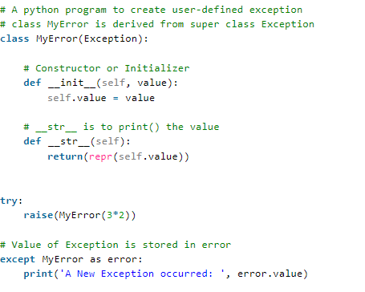
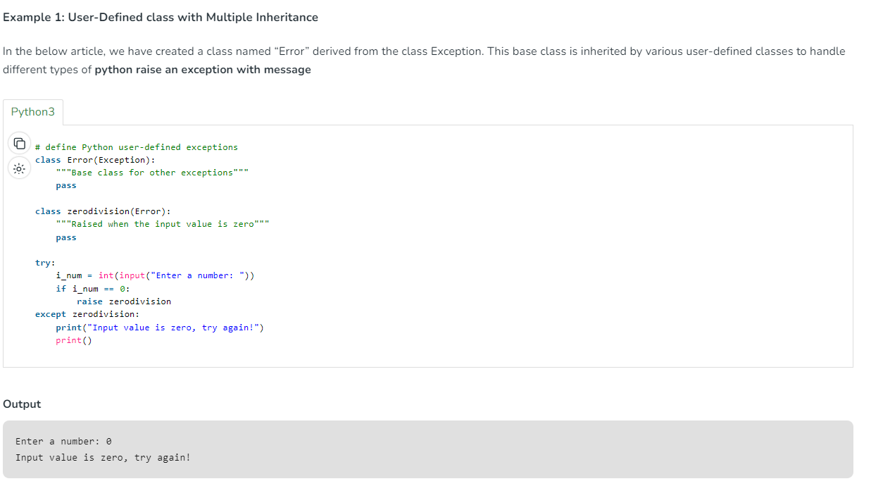
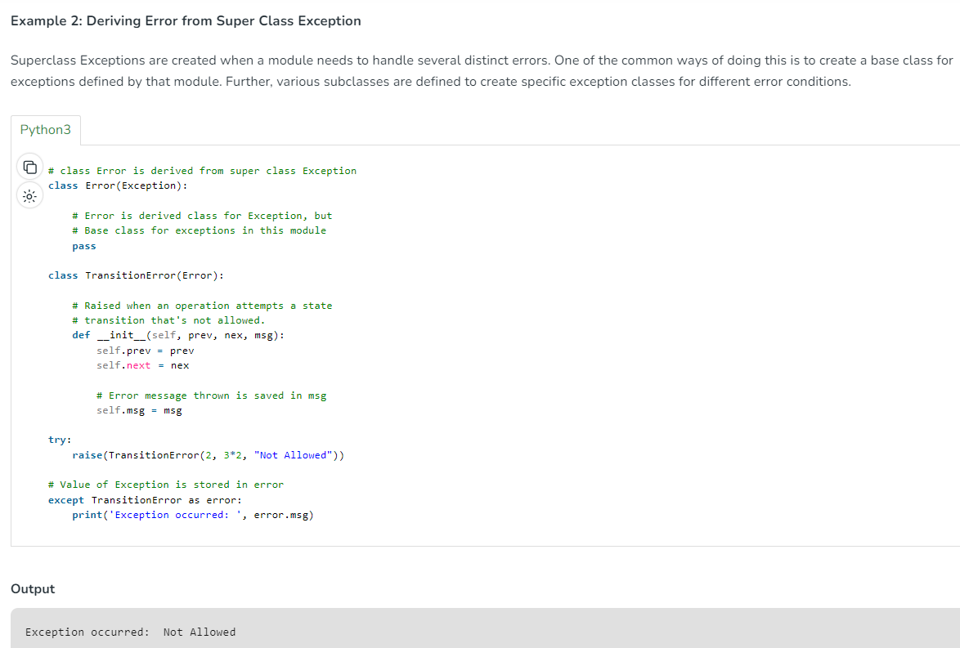

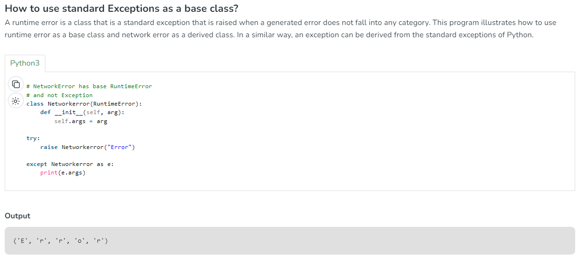

Advantages of Exception Handling:
- Improved program reliability: By handling exceptions properly, you can prevent your program from crashing or producing incorrect results due to unexpected errors or input.
- Simplified error handling: Exception handling allows you to separate error handling code from the main program logic, making it easier to read and maintain your code.
- Cleaner code: With exception handling, you can avoid using complex conditional statements to check for errors, leading to cleaner and more readable code.
- Easier debugging: When an exception is raised, the Python interpreter prints a traceback that shows the exact location where the exception occurred, making it easier to debug your code.

Disadvantages of Exception Handling:
- Performance overhead: Exception handling can be slower than using conditional statements to check for errors, as the interpreter has to perform additional work to catch and handle the exception.
- Increased code complexity: Exception handling can make your code more complex, especially if you have to handle multiple types of exceptions or implement complex error handling logic.
- Possible security risks: Improperly handled exceptions can potentially reveal sensitive information or create security vulnerabilities in your code, so it’s important to handle exceptions carefully and avoid exposing too much information about your program.

